**CENWP-OD-B 11 July 2023**

**MEMORANDUM FOR THE RECORD**

**SUBJECT: 23BON052 MFR AFF Valve 15 Lamprey Mortalities**

In the afternoon of 11 July, Columbia River Inter-Tribal Fish Commission (CRITFC) Biologists notified Bonneville Project Biologists of three lamprey mortalities found on the valve 15 trash rack in the Adult Fish Facility (AFF). The fish were scanned for PIT tags, inspected, and returned to the river.

1. 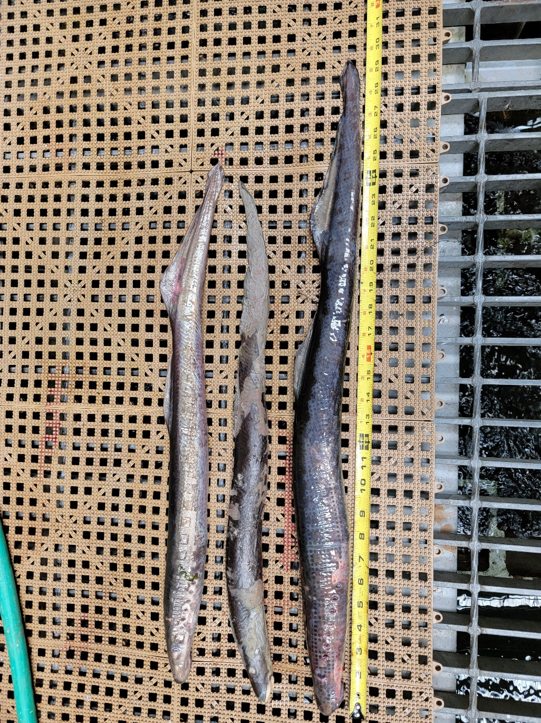Species – Pacific Lamprey (*Entosphenus tridentatus)*
2. Origin – Unknown
3. Length – In descending order in the picture: 61.7 cm, 62 cm, 75.2 cm
4. Marks and tags – None
5. Marks and Injuries found on carcass – None
6. Cause and Time of Death – Unknown
7. Future and Preventative Measures – None

Sincerely,

Bonneville Project Fisheries